- Abstract
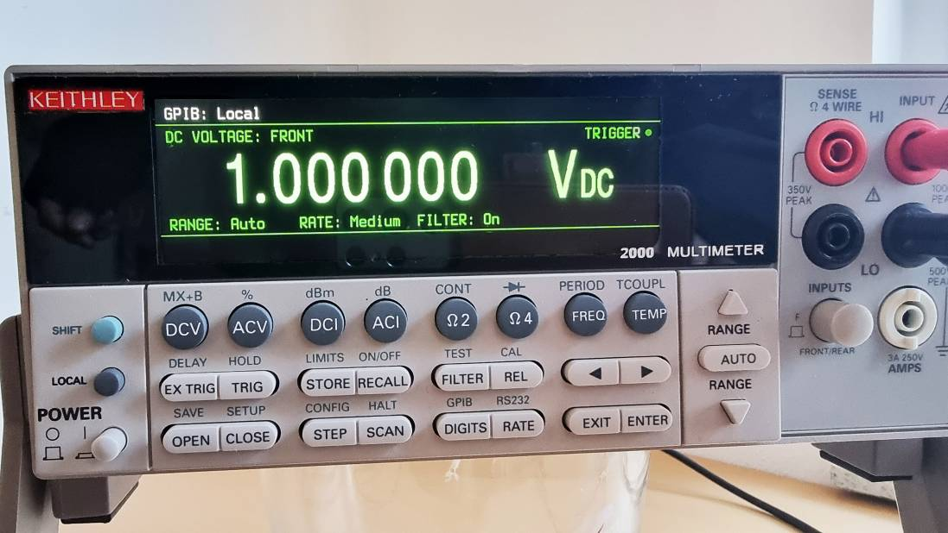
The aim of this conversion guide is to modify a Digital Multimeter KEITHLEY 2000 from the original VFD display to a color TFT Display. The TFT display fits into the Bezel without any major changes.
The new function compatible PCB replaces then original PCB completeley. A STM32 Controller handles the communication with the main board, decodes the serial protocol for the measurement presentation and the Annunciator Bits, controls the TFT display and generates the code when a key is pressed.

- Resources
The following materials are essential to perform this modification:
- a functional KEITHLEY 2000 Digital Multimeter with Firmware A20 (older versions not tested)
- clear Acrylic Glass sheet, 162mm x 42mm with a thickness of 3.0mm
- assembled and tested PCB “K2000 Display Board TFT”
- a new ribbon cable front PCB to KEITHLEY 2000 main board
- EastRising Bar Type 4.58 inch 320x960 IPS TFT LCD Display with NO Touch Panel, ER-TFT4.58-1
- EastRising LT7680 Graphics Acceleration Control Board, ER-PCBA5981-x
- Programmer capable of in circuit programming of a Winbond W25Q128 serial FLASH
- adapter cable Graphics Control Board to Programmer
- ST-Link Programmer and ST-Link Utility programming Software
The data set of this conversion guide consists of:
- this conversion guide including the schematics, bill of material and component placing
- a Zip-File containing the Gerber Files for manufacturing the PCB
- a Intel-Hex file to program the on board STM32 controller
- a binary file to program the Winbond Flash on the Graphics Control Board which holds images and character sets
- a ZIP file holding the data for cutting the outlines and lettering of the front Acrylic Glass, a drawing to carry out the blackening of the front Acrylic Glass and an image file containing the correct sized and colored KEITHLEY logo in order to make a Decal.
- Mechanical
The Bezel of the KEITHLEY 2000 must be completely detached from the device and the original Front Circuit Board with the VFD and the keyboard mat must be removed.
For the operation of the TFT, the Acrylic Glass must be replaced. The original Acrylic Glass has a light transmission of about 40%, which is suitable for increasing the contrast of a VFD, but is not suitable for a TFT display, which offers an acceptable contrast but does not have such high brightness.
The new display cover should be made of clear Acrylic Glass measuring 162mm x 42mm, with a thickness of 3.0mm (2.5mm would be ideal, but that's hardly available). In the manufacturing process, the cut edges should be polished.
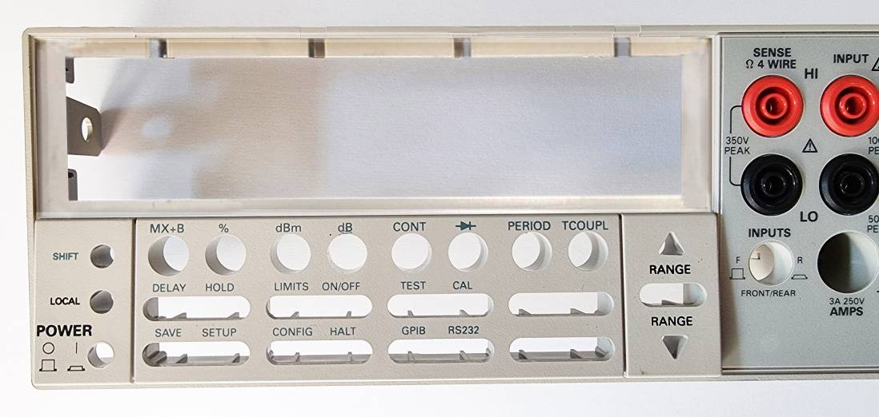
In order to get the original Acrylic Glass out, some violence is required. The Acrylic Glass is attached to all contact surfaces with double-sided adhesive tape. The use of hot air cannot be recommended, the Bezel could be deformed which leads to an irreparable damage. So you have to carefully try with heavy thumb pressure from the inside to the outside to first find a place where the bonding dissolves, then continue working from there without damaging the Bezel. Once the original glass is out, the adhesive residues must be removed from all parts.
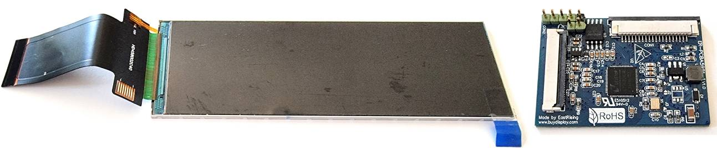
The Bar Type 4.58 inch 320x960 IPS TFT LCD Display is available from EastRising (BuyDisplay). It has a built in ST7701S controller with a 3 wire SPI interface. The additional LT7680 Graphics Control Board is capable of a high performance graphics acceleration supporting many geometric graphics functions, custom character sets, has an embedded 128Mb Display RAM and supports direct memory transfer. An additional 128Mb serial Flash Winbond W25Q128 can hold graphics and character sets to be transferred to the Graphics Controller RAM on runtime.

The LCD fits exactly into the KEITHLEY Bezel in height, so minor mechanical work has to be done. The LCD has to be positioned in the center of the Display Window with reference to its center of the visual area which is asymmetrical arranged to its outline.
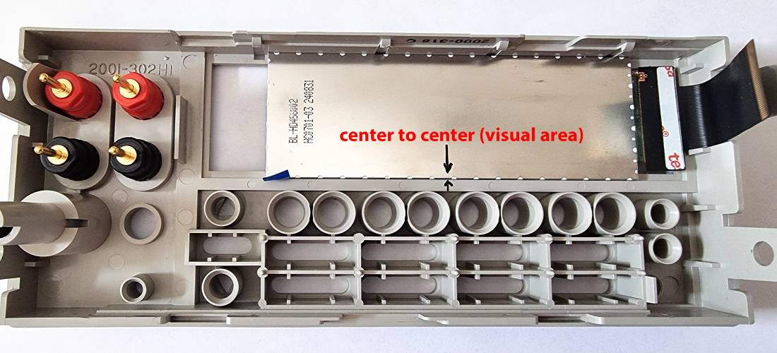
Some spacers should be glued into the frame from the inside to hold the LCD into its horizontal position. With a length of 20mm on the inside-left and 16mm on the inside-right the LCD is perfectly positioned and fixed.
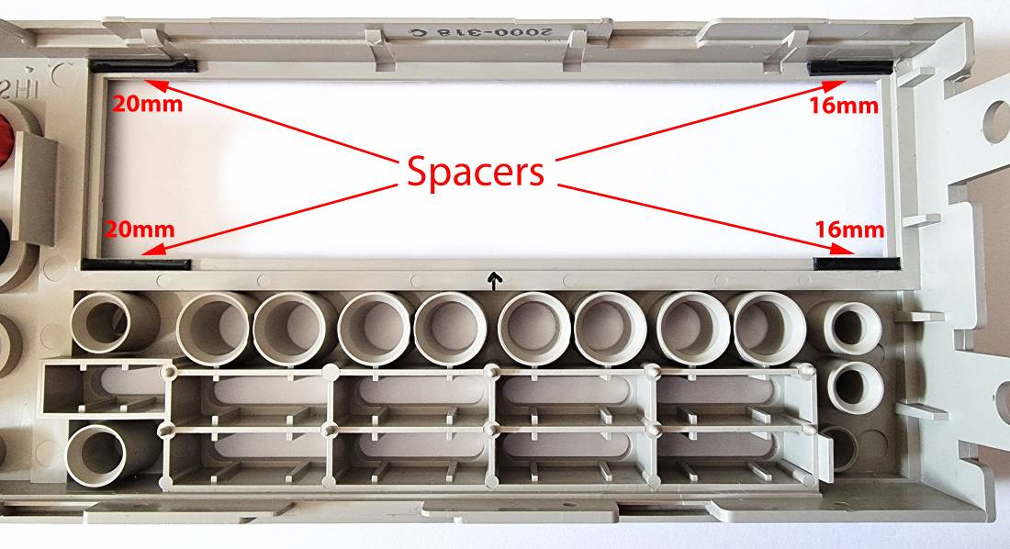

Since the original Acrylic Glass is replaced by a transparent one, all surfaces and edges visible through the Display Window should be painted black because they are now visible through the clear Acrylic Glass. For this purpose, matt black lacquer, sprayed (using masking tape) or applied with a brush (as shown) is suitable.
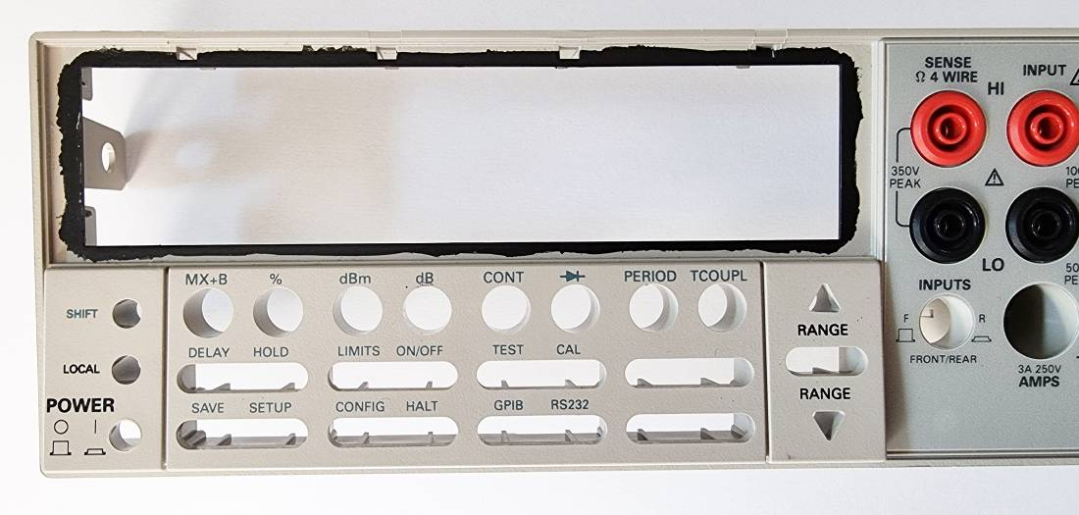
The blackening should be done from the inside and outside. No beautiful appearance needed.
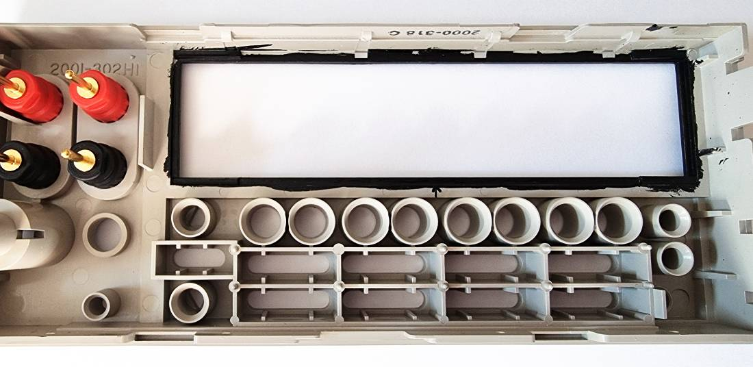

The new Acrylic Glass must have a back blackening too. Regarding the left and the right side the visual area of the TFT should be seen only. At the top and bottom area it must cover the frame only. That’s why some parts of the TFT active area are already hidden by the Bezel frame.
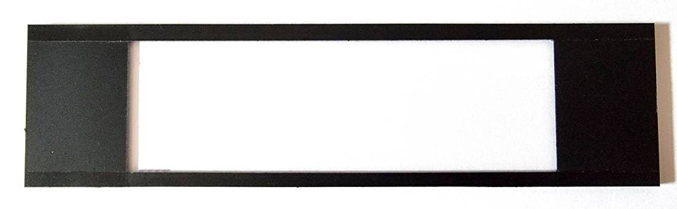
The following is for those who aim for perfection:
If you have a CNC you could mill the Acryl Glass by yourself out of a sheet. By doing this you could also mill the lettering “2000 MULTIMETER” on the front side using a 0.3mm milling cutter. This idea is based on the fact, that probably no one has a white toner cartridge for his laser printer to make a white printed transparent decal.
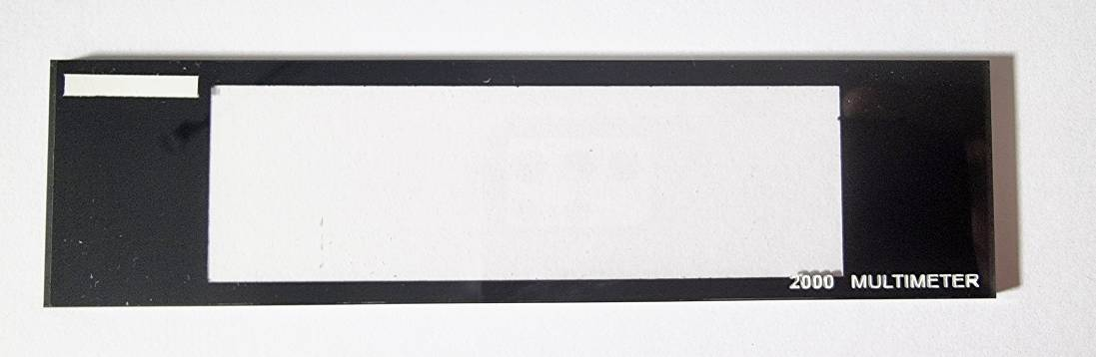
By filling the lettering with white lacquer the caption “2000 MULTIMETER” will be fully visible. A white rectangle sprayed on the opposite side is used as a background for a red printed transparent decal representing the lettering “KEITHLEY”.
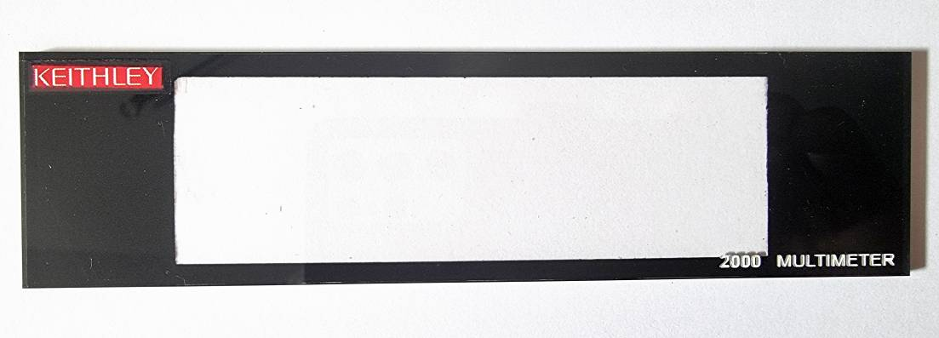
With the decal in its position the transparent Acrylic Glass looks nearly perfect, very close to the original.
The new Acrylic Glass now can be fixed into the Device Front by using thin transparent double sided sticky tape. Finally the new Device Front is now ready to be used with the new hardware.
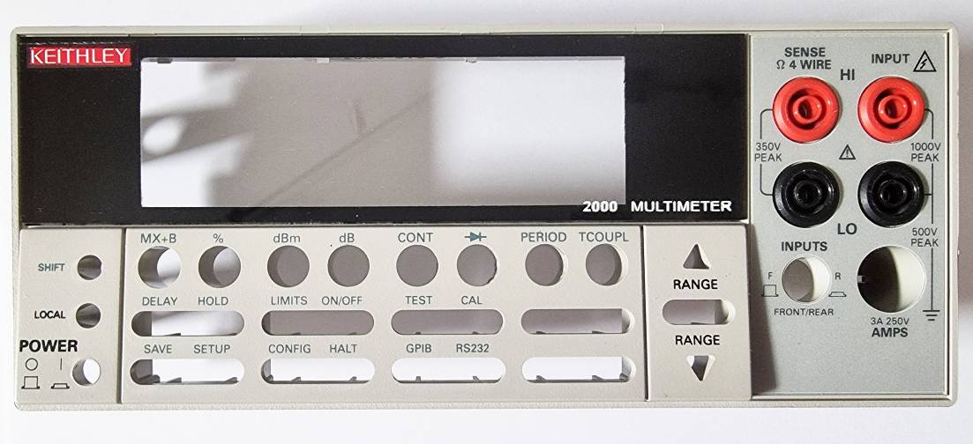

- Electronic Hardware
The PCB “KEITHLEY 2000 Display Board Replacement TFT” must be assembled in accordance with the associated Component Placement and the Bill of Material (see Appendix).
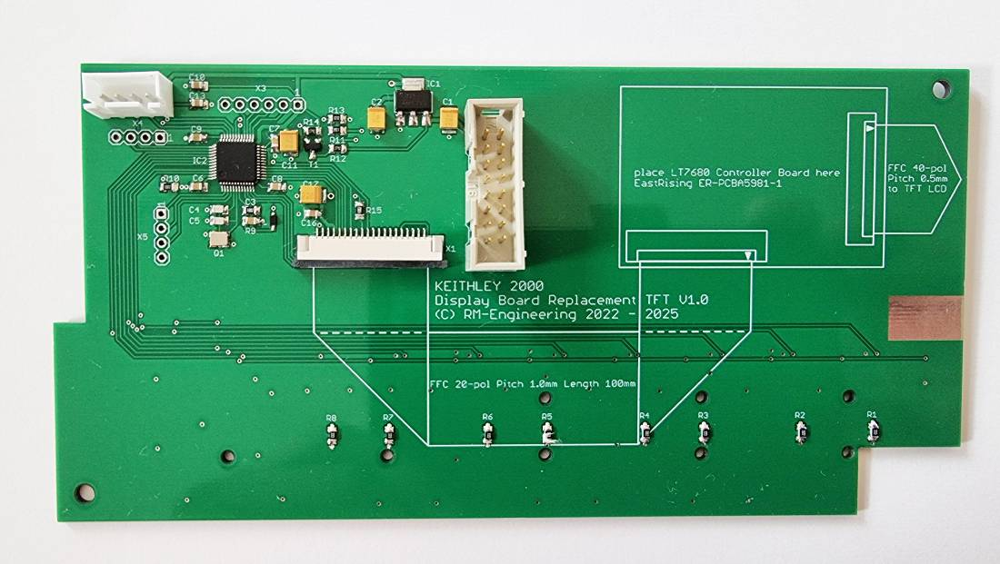
The EastRising Graphics Control Board has to be placed using double sided mounting tape in its intended position. Before that, don’t forget to assemble the JP1 connector to the Board to be able to program the serial Flash later on. The Jumper Cable FFC 20 Pin 1.0mm Pitch listed in the Bill of Material has to be mounted as shown.
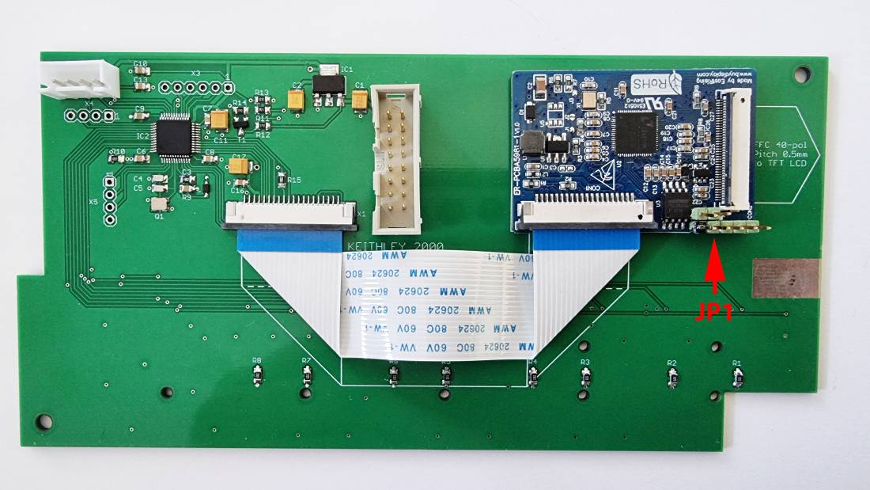
Finally a 16-pole ribbon cable, length approx. 270mm between the plugs, with a 16-pin socket plug on both sides must be produced. The cable connects the new display board to the main board. The socket plugs must be pressed in such a way that a pole-correct connection can be established (connection pin 1 to pin 1). If the ribbon cable is made and folded as shown in the picture, this fits exactly into the device.
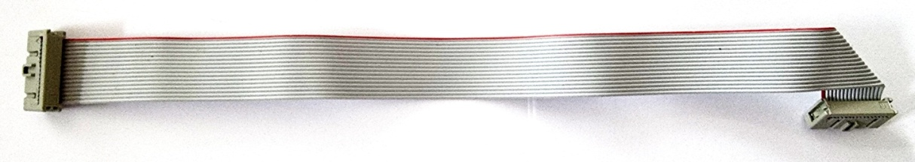
- Front Assembly
Now the TFT can be set in its position.
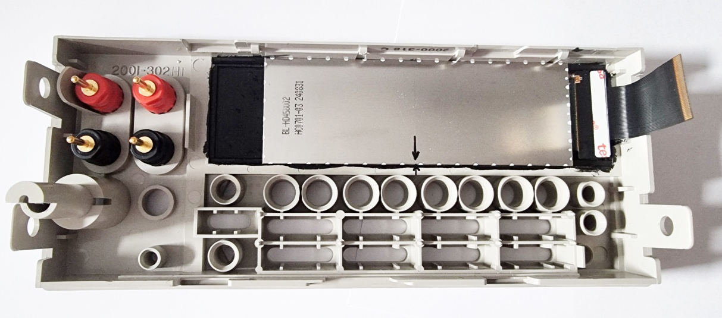
A suitable piece of non-conductive foam to be compressed between the TFT and the PCB will hold it in position. The key mat can also be reinserted, don’t let the foam get in the area of the key mat.
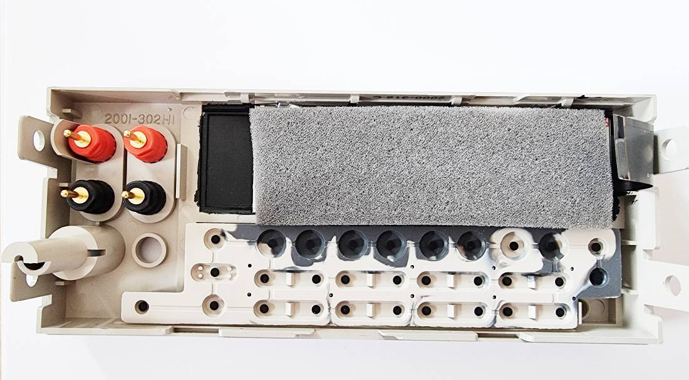
After the PCB has been placed in, the EastRising Graphics Control Board must be connected to the LCD via its 40 pin FFC cable as shown.
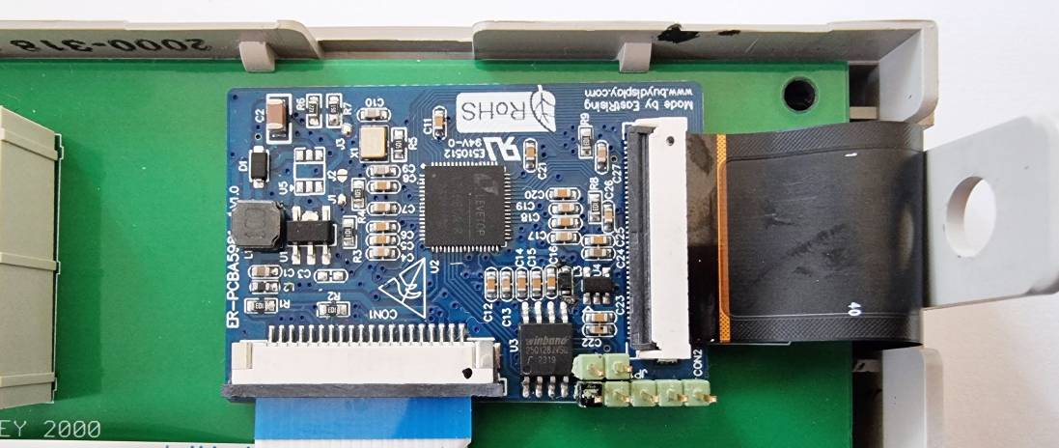
Now remount the completed KEITHLEY 2000 Device Front back to the Device and establish the Ribbon Cable connection to the main board.
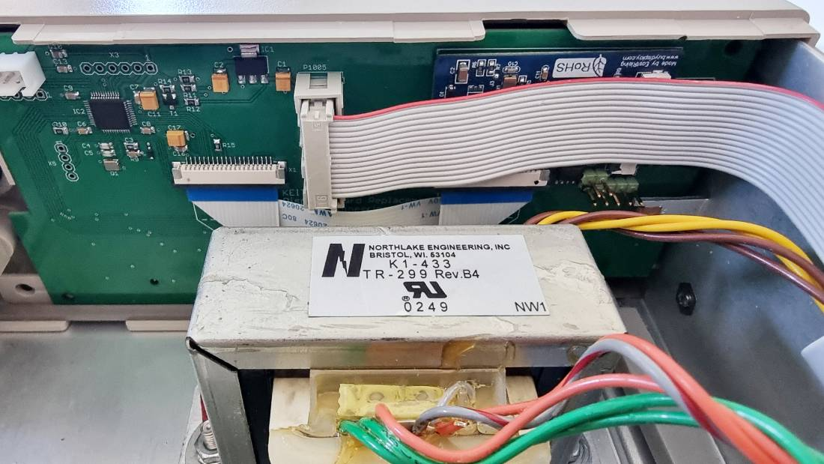
That completes the mechanical and electrical work of this conversion tutorial.

By replacing the original Acrylic Glass and the original PCB you can reset your device back to the factory state at any time without any visual or functional losses.

- Programming the Flash Memory and the STM32 Firmware
After completion of the assembly the Flash on the Graphics Control Board and the STM32 must be programmed. During the programming work the front board must be supplied with power from the KEITHLEY 2000 or any other source because most programmers would not be able to power the complete 3.3V power rail.
Start with the Flash on the Graphics Control Board:
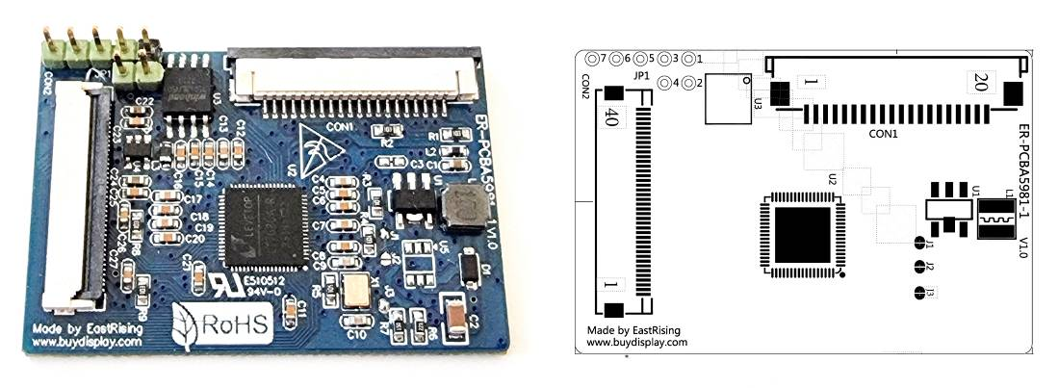
There is a Winbond W25Q128 a 128Mbit 8 Pin serial Flash which holds some graphics and all the Character Sets used for this application. Program the flash data to the serial flash starting at address 0x000000, the complete data range is 0x000000 to 0x030FFF. Be aware that the original content (some pictures and Chinese character sets) will be replaced. If you want to keep the original contend for any reason, first read the device and save the content before programming the flash.
For a standard programmer connect the JP1 to a 8 pin IC socket as shown below.
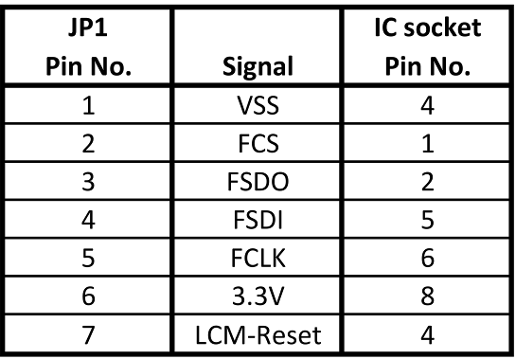
Make sure that the Controller reset line LCM-Reset is connected to VSS (GND) to keep the Controller away from accessing the flash during programming.
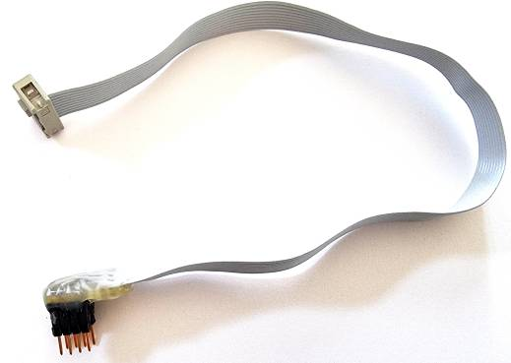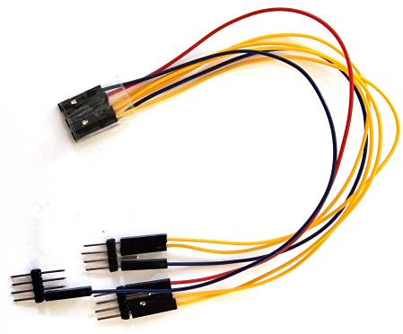
You can build a special cable to do the programming. Different from me you would do this only once, so some jumper cables would be the right choice.
Finally program the STM32 Controller:
You have to have installed the STM32 ST-Link Utility Software on your PC, connect your programming device to the ST-Link connector according to the specified signal names, connect to the target, load the firmware file and do the programming.
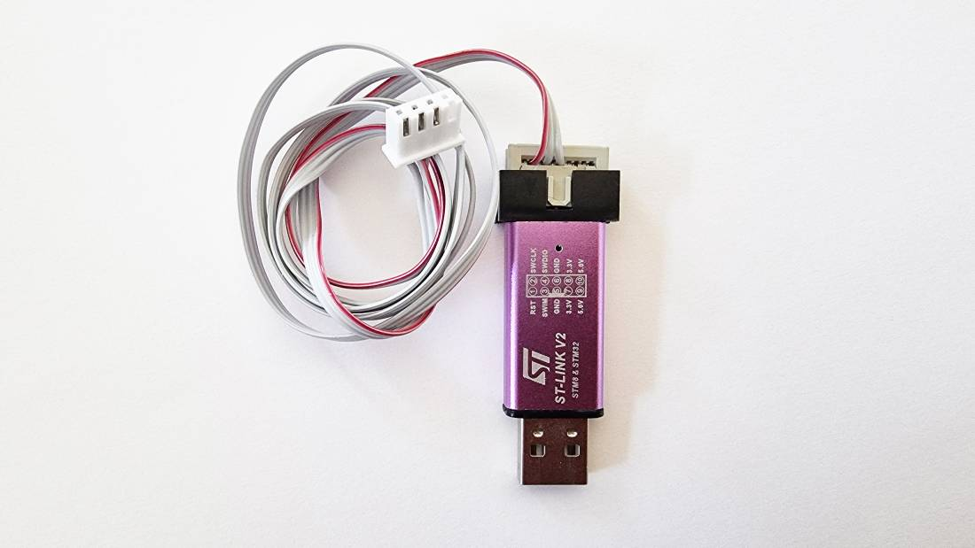
This completes the whole conversion process and after a power cycle the KEITHLEY 2000 should do its job with the new TFT display.

- Author’s Comment
The software may not be error free. It has not been tested in remote control mode via GPIB or RS232. Some additional display elements rely on the evaluation of local keyboard entry, therefore limitations may occur during remote control operation. It was created on a KEITHLEY 2000 with the latest firmware A20. It's likely that it will also work on older firmware versions. I would appreciate any feedback on this. In general, I welcome any bug reports or comments related to this project.

Appendix 1: Schematic
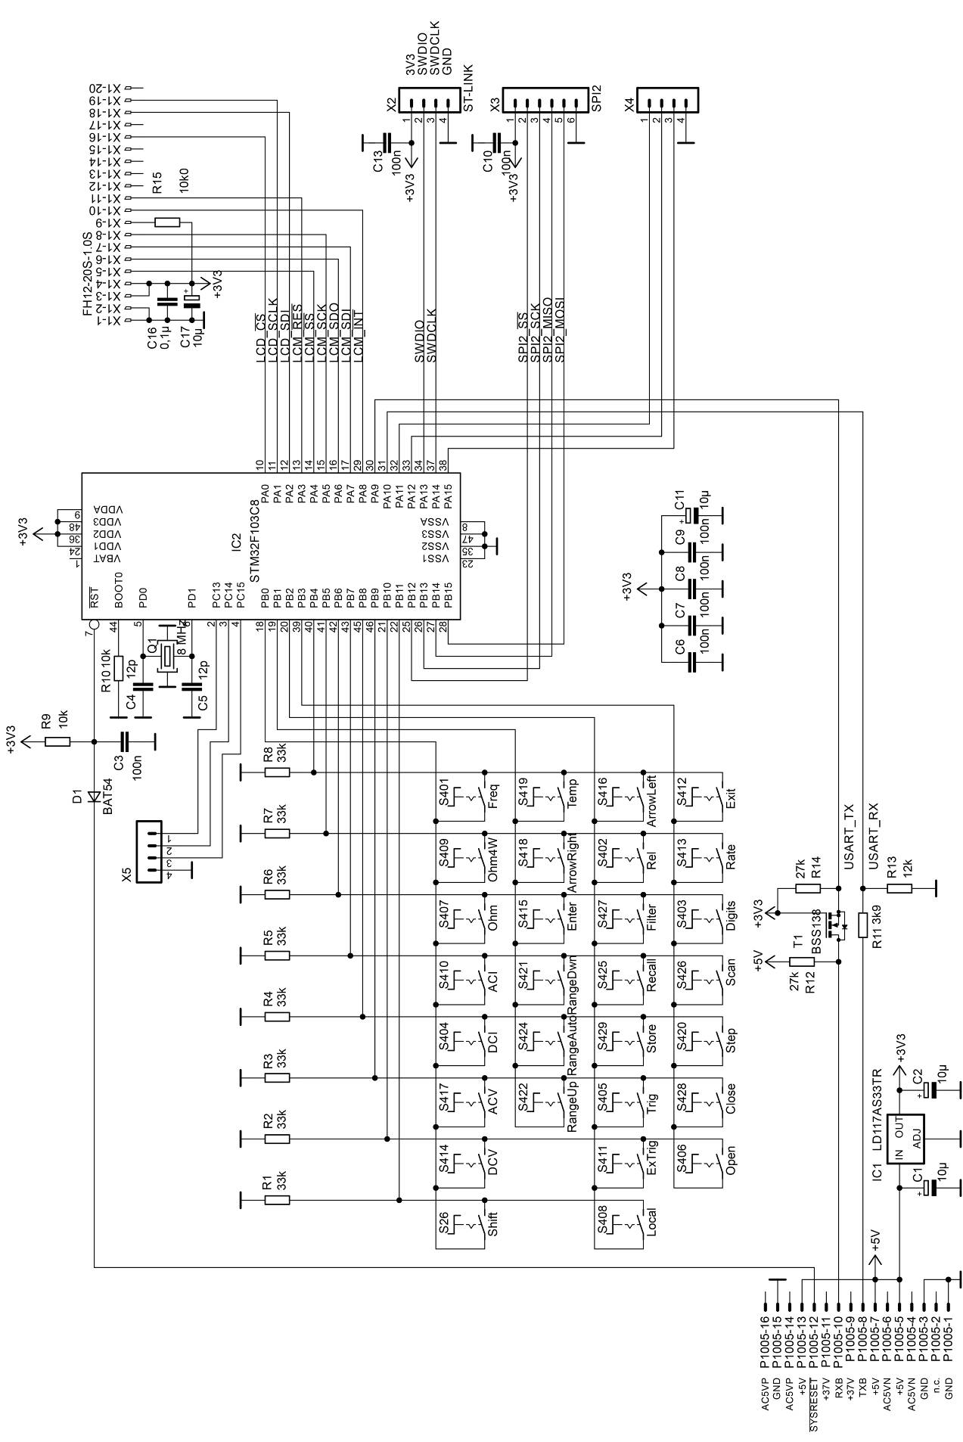
Appendix 2: Component Placement
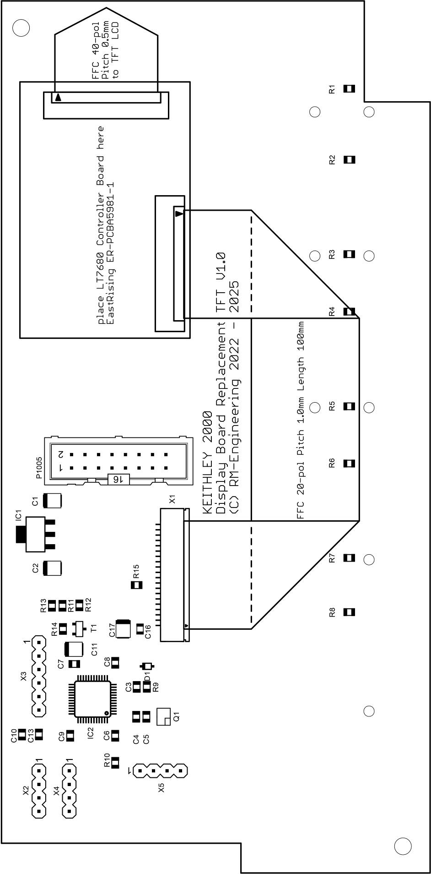
Appendix 3: Bill of Material
